Home Makeover Series “IKEA Home Tour” Now Casting in Maryland/Virginia
IKEA Home Tour is Casting Season 4

One room. One dream. One total makeover. Is your home in need of a major upgrade? IKEA is here to help! The IKEA Home Tour squad is looking for homes in the Maryland/Virginia area with organization, storage and style challenges. We’re sending a team of IKEA experts on the road to help America solve real home furnishing problems and transform living spaces and lives along the way. Home projects can include anything from small-space organization to stylish makeovers where the IKEA Home Tour Squad will show how smart solutions can make everyday life at home better! They specialize in everything from home design to organization and creative DIYs to help you transform your space.
The Squad will work with you to create a design plan and shop for the furnishings and accessories you’ll need from the local IKEA store. You’ll then accomplish the makeover together! Plus, the Squad will film their journey along the way.

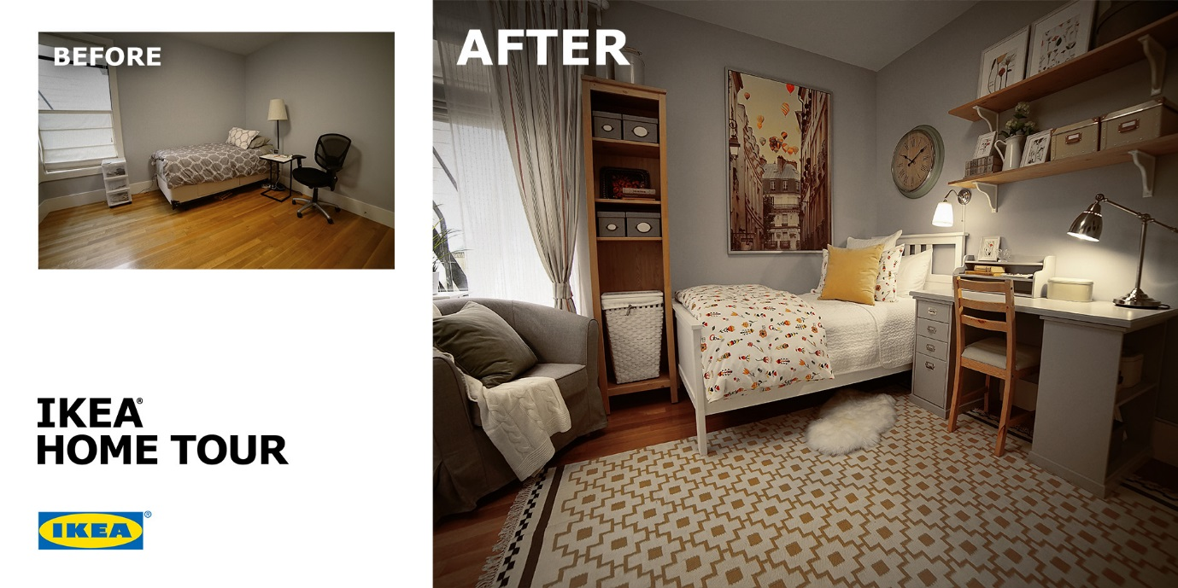

Interested in an IKEA Home Tour makeover? Submit here: https://www.hometourseries.com/submit
For more information, visit https://www.hometourseries.com/.

