Phil 413 Productions Presents:

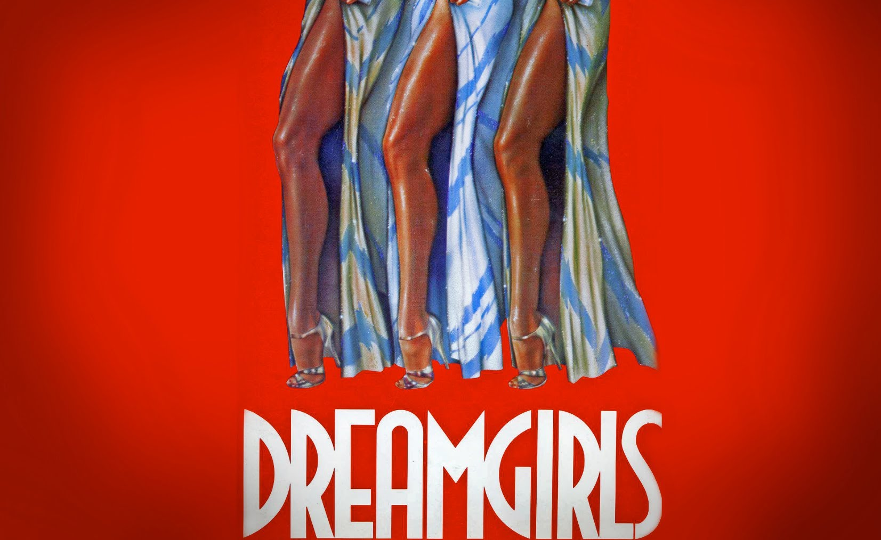

**The Musical Auditions**

October 10th and 11th at 6:00pm

**Please Prepare:**

*A 16 to 32 bars of a song in the style of the show

(Please do not sing from the show)

Accompanist will be provided or you can bring a CD

*Head shot and Resume stapled together

*A 50-70 word Bio

**Location:**

17555 Mauna Loa st. Hesperia CA 92345

**Show Dates:**

January 19-22nd 2017 at the High Desert Center for the Arts

15615 8th street Victorville CA

**For more information and character breakdowns please visit:**

**https://www.facebook.com/phil413pro/**