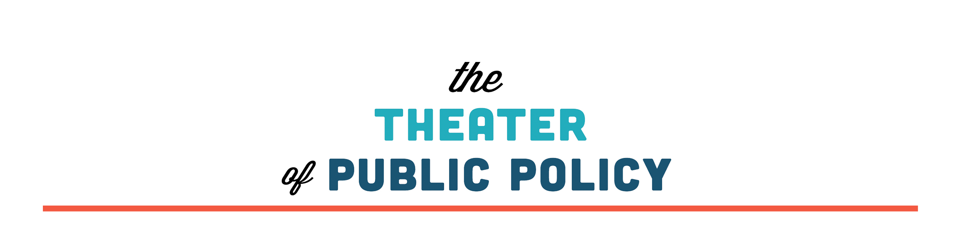

SPRING SEASON
AUDITIONS

SUNDAY Nov 27,
1 p.m. – 2:30 p.m.

or

MONDAY Nov 28,
9 p.m. – 10:30 p.m.

Call backs: WEDNESDAY Nov 30, 7 p.m. – 9 p.m.

Bryant Lake Bowl Theater

The Theater of Public Policy (T2P2 for short) is one of Minnesota’s favorite (and coincidentally only) civics-inspired improv comedy companies.

Audition to join the team for their spring season: January–April, 2017.

T2P2 will have shows every Monday in March & April, and typically has four to six remote gigs each month.
T2P2 pays its cast for all performances.

T2P2 is specifically looking for prospects from communities currently under-represented in the Twin Cities theater community.
R.S.V.P./Questions: Teresa@t2p2.net

