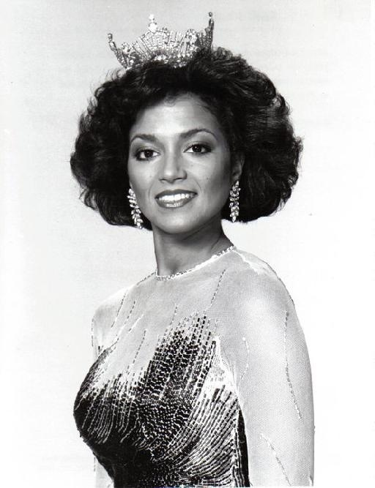
Seth Green began taking
workshops with us at WBR at the age of 7. (You can see him in Buffy The Vampire Suzette Charles:
WB-Ryan
STARS
Slayer, Austin Powers, Radio Days, Scooby-Doo 2, Miss America 1984
Robot Chicken, Family Guy) Suzette took Soap Opera Acting
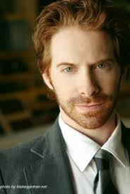
at our Atlantic City office. She is from Mays Landing, NJ!
Look Who's Studied At
Weist-Barron-Ryan



Courtney Cox was just another
student in one of our workshops in
the mid 80’s. Now she’s a household

name. (Cougar Town, Friends,
Dirt on FX,)

Tabitha Cortopassi (Galloway, NJ) 2X Emmy Winning choreographer

WBR Alumni and creator of Urban Dancewear, “Lyrical Hip-Hip”, the driving creative force behind
MTV's hit show America's Best Dance Crew. She has worked on Dancing With The Stars, Disney's
Shake It Up, America's Got Talent, Suburgatory and X Factor. on-camera hosts/judges for Mobbed,
TLC's Rock The Reception, and MTV's Beyond Dance. Additional TV credits include producing both
American Idol & Sing Your Face Off. She has provided creative direction & choreography for Grammy's,
the Emmy's, American Music Awards, Billboard Music Awards, Teen Choice Awards, & Kids
Choice Awards. Tabitha works with top music artists including Michael Jackson, Jennifer Lopez,
Beyonce, Christina Aguilera, Arianna Grande, Jesse J, Ed Sheeran, Prince, Carrie Underwood,
Celine Dion, Sean Kingston, 50 Cent, Ricky Martin, and Madonna's 2012 Superbowl Halftime Show.
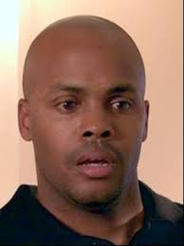
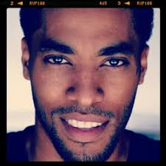
Mushond Lee, (Smithville, NJ), Jameel Saleem (South Jersey)
NBC's Sunset Beach”, Cosby Show, South Park Character & Writer,
Behind Enemy Lines, Charlies Angels Starring in “Exit Strategy” w/
Full Throttle, Lean On Me, National Kevin Kevin Hart, Telenovela Writer, & more!


Folgers Coffee Commercial, & MORE!

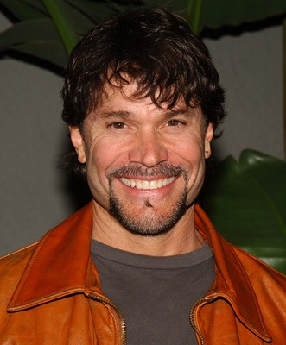
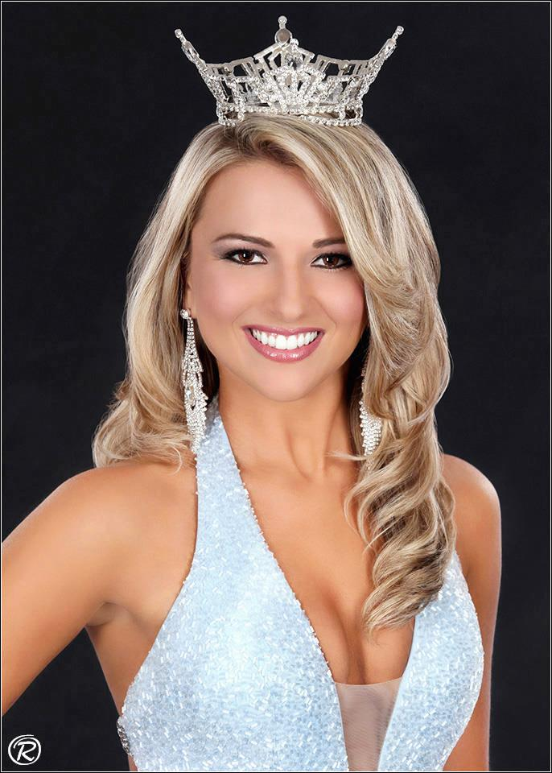

Kaitlyn Schoeffel Peter Reckell
MISS NEW JERSEY 2017 Peter was doing odd Jobs for Bob
Weist-Barron-Ryan Alumni Barron in NYC when the soaps
Kaitlyn (and her mother) are WBR family called for him. He played the
studying acting as well as Pageant Consulting! very popular “Bo Brady”
DAYS OF OUR LIVES for
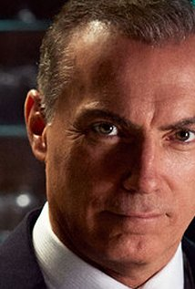
Decades!

Al Sapienza- Al studied with WBR
and still comes to the Atlantic City Cinefest
to honor us. He can be seen frequently on
Sopranos, House Of Cards, Brotherhood,
Person Of Interest, Suits, Blue Bloods,
and is shooting several projects currently.

