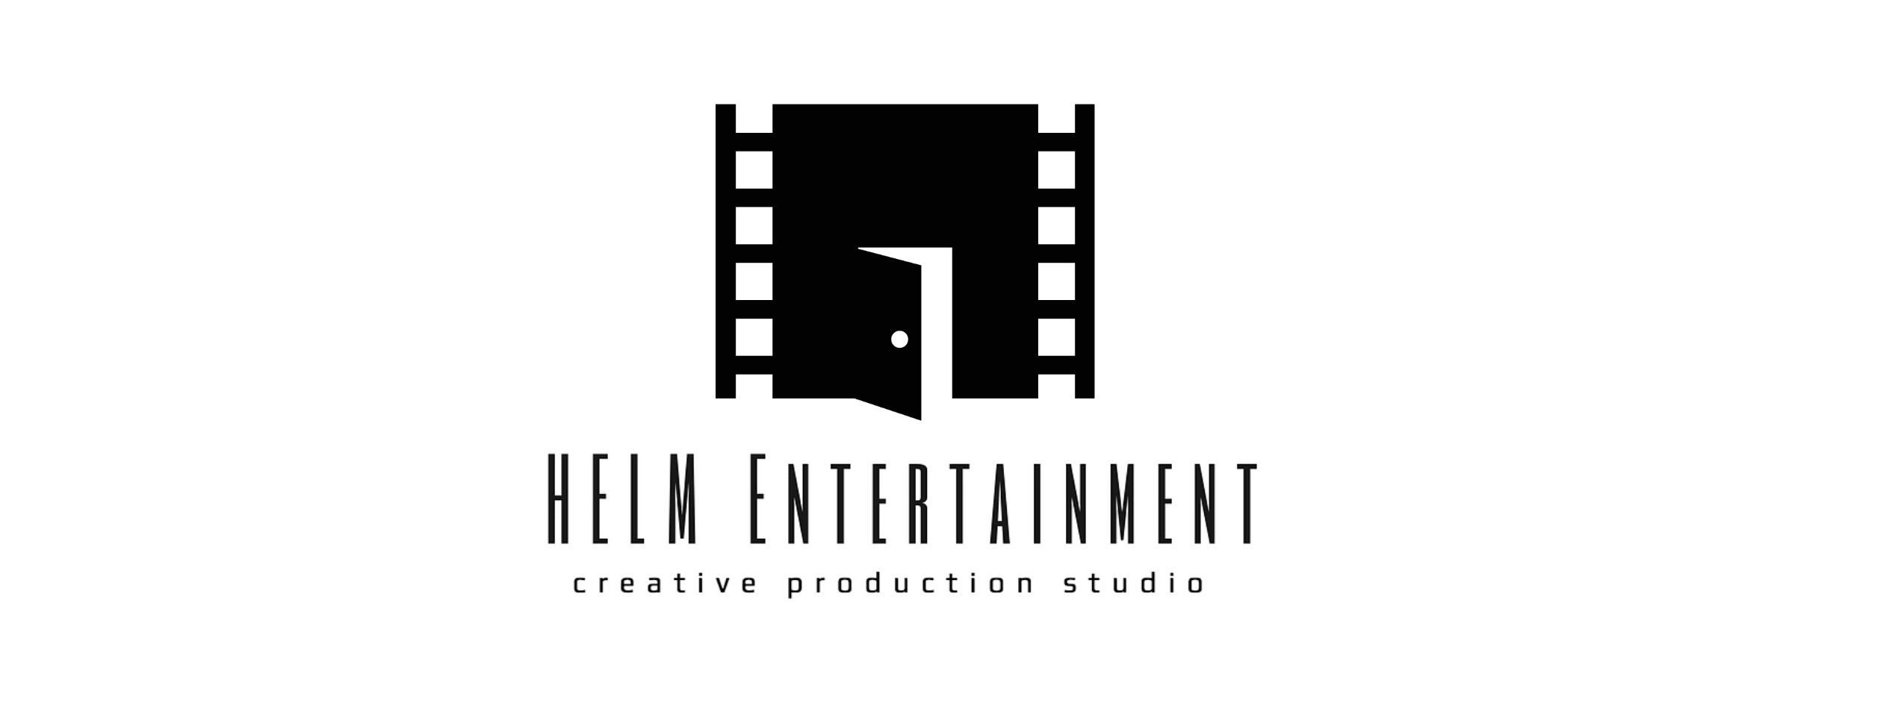

RELEASE FORM
To: [HELM Entertainment]

I hereby consent to my name, likeness, image and voice being interviewed, recorded, photographed, filmed and taped by you via picture and sound, together with any and all information, biography, photos or materials of any nature provided by me (collectively the “Contributions”) for the television or film production being produced by you, presently entitled “[Who we are –Music Video]”(HELM Entertainment”), and hereby grant the following rights to you as evidenced by my signature on this release (the “Release”):

You have the right, but not the obligation, to exhibit, exploit, advertise and translate the Production, together with my Contributions to it, throughout the universe in perpetuity and in all languages, in and by any and all means or forms of media now known or in the future discovered, including sequels, prequels, remakes, serials, adaptations and all ancillary and subsidiary rights thereto (including without limitation, linear and non-linear CD-Rom, CDI, Internet, electronic publishing and other interactive media products). You may freely use, translate, adapt, revise, add to, edit and subtract from the Production and my Contributions to it and any information, material, scenes and/or situations contained in it and/or furnished by me to you. You may freely at your sole discretion assign, license, transfer or otherwise dispose of or exploit any of these rights in whole or in part without notice to, or further consent from, me being necessary. You may also use in your sole discretion, the Production and my Contributions to it, including my name, likeness, image, voice, biography, photographs and recordings of me in all languages and all forms of media now known or in future discovered, throughout the universe, in perpetuity, in advertising and promoting the Production.

I waive and relinquish all rights and remedies at law or in equity, including moral rights, and release and forever discharge you and all others dealing with you from, and agree not to sue you or any of them, with respect to any claim, cause of action, liability, loss or damage of any nature whatsoever arising out of your exercise of the rights granted herein, including claims relating to defamation or invasion of any right of copyright, privacy, personality or publicity. In no event shall I be entitled for any reason whatsoever to enjoin, restrain or interfere with the distribution and/or exhibition and/or exploitation of the Production or its advertising or publicity.

Other than the consideration set out above, I agree that I shall receive no compensation or payment whatsoever with respect to the Production.

I acknowledge that I am not a member of ACTRA or any other similar union or guild.

I have read and understand this Release prior to signing and I am fully familiar with all terms herein and I warrant and represent that I have the full right, authority and capacity to sign this Release and grant the rights granted herein.

This Release shall be governed by the laws of the province of [Quebec] and the country of Canada.

I declare that I am not under the age of eighteen (18) years. Insert Initials: __

Date: ________________, 2020__

Signature: _____________________________ Witness Signature:_______________ ___________________
Name (Print): __________________________ Witness Name:_____________________________________

Address: ______________________________________________________________________________

Telephone: __________________________ E-Mail Address: ____________________________________

If under 18 years of age: Parent or Guardian Agreement I have read, understood and agreed to the foregoing. I represent and warrant that I am the parent or legal guardian of the individual named in the above Release who is a minor and that I am entitled and authorized to sign this Release and grant the rights granted hereunder to you. I indemnify you, your successors and assigns against any loss or claim if the minor disavows the Release because the minor was a minor or for any other grounds whatsoever.

Signature: _________________________________ Witness Signature: ________________________

Name (Print): _______________________________ Witness Name: ______________________

