CASTING CALL

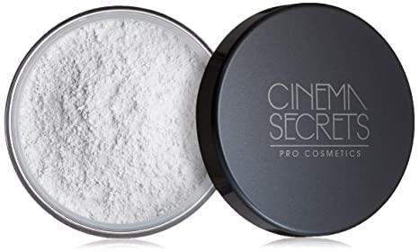Powder my Nose

Location TBA- Shooting Dates TBD

Powder My Nose is a Comedy, Short film about four friends who go on a double date, one is a blind date. Jennifer and Laura are best friends. Jennifer is married. Laura is single and Lactose intolerant but still eats dairy.

**Jennifer** (Female, 20's-40"s, Brunette, Any Ethnicity)  
Confident, married, feminine, sassy, over the top. Think Sofia Vergara, Sasha fierce Beyonce’s alter ego.

**Richard** (Male, 20's-40's, medium build, Athletic, Any Ethnicity) Manly,  
Calm, cool, handsome, married to Jennifer.

**Man** (Male, 20's-40's, Any Ethnicity)

**Waiter/Waitress** (Male, female, 20's-50's, medium build, Athletic, Any Ethnicity)

**Hostess** (Female, 20's-70"s, Any Ethnicity) Looking for an actress that can do an accent.

**Richard’s parents** (Male, and Female, 50's-70’s, Brown, Tan, Copper, Olive Complexion)

**Jennifer’s parents** (Male, and Female, 50's-70’s, Brown, Tan, Copper, Olive Complexion)

**Extras** (Male, Female, 20's-80’s)

**Atmosphere** (Male, Female, 20's-80’s)

This Film will be screened at CCBC Essex’s film festival and other festivals. To schedule an audition please send headshot, resume, and contact info to: [wi1108400@email.ccbcmd.edu](mailto:wi1108400@email.ccbcmd.edu) This is a Non-Union, Unpaid Job. I will Provide a copy for reels and provide credit.