Yankees Entertainment & Sports Network

Presents

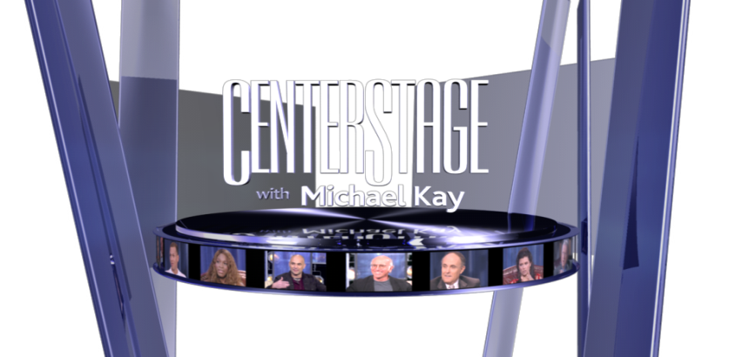
Be a part of our NYC studio audience for an EXCLUSIVE taping with
Emmy Award Winning Actor
Bobby Cannavale

FREE VIP TICKETS!!!

SHOW DATE: Tuesday, February 24, 2015

SHOW TIME: 1:00 P.M. (Arrival time is suggested at least an hour and a half, prior to show time.)

STUDIO LOCATION: AMV Unitel Studios
515 West 57th Street (between 10th & 11th Avenues)

R.S.V.P. – CenterStage@YESNetwork.com (with name, phone and email address)
(Please mention you received this flyer)
Information Line: 212.871.9265 (YANKS)

CenterStage focuses on superstars of sports and entertainment as they appear on stage in front of a studio audience to talk with Michael Kay about their lives as major sports and entertainment figures. The YES Network has produced more than 125 episodes of CenterStage which provides viewers with a one-hour sit-down with their favorite celebrities ranging from
Derek Jeter, Jon Bon Jovi, Joe Montana, Jerry Rice, Serena Williams,
Billy Crystal, Charles Barkley, Sylvester Stallone, Michael Douglas,
Dan Marino, George Foreman, Yogi Berra, Oscar De La Hoya
Jay-Z, Regis Philbin, Quentin Tarantino, Emeril Lagasse & Tino Martinez and more….

For more information go to: www.YESNetwork.com

