Galveston County

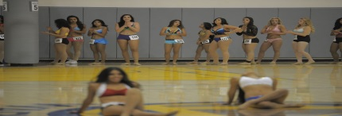
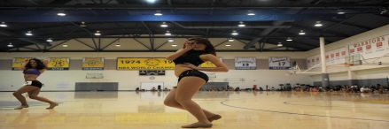
Lady Monarchs
Cheer/Dance
Auditions
Must be 18 & Older
Registration Fee: $25

Information Meeting: Friday, November 20, 2015
Time: 7pm
Information Meeting Location: TBA

Audition Date: Saturday, November 28, 2015
Audition Location: TBA

To Pre-Register Email: GalvestonLadyMonarchs@gmail.com
For more information call 832-206-8217 or 409-999-0132

