AMERICAN YOUTH CHORUS
AUDITIONS
for 2016-2017 Concert Season

Weekly After-School Music Program, for ages 8-14, in our 9th Season

Committed to making music of the highest artistic quality
in an environment that is Creative, Supportive and Fun!

Auditions & Weekly Rehearsals at
Capitol Hill Arts Workshop (CHAW)
545 7th Street, SE, Washington, DC

To schedule an audition, email aycmanager@congressionalchorus.org
or call AYC Manager Susan Kennedy at 301-502-4952

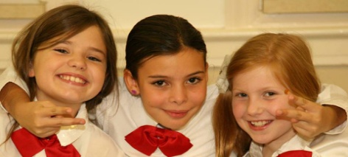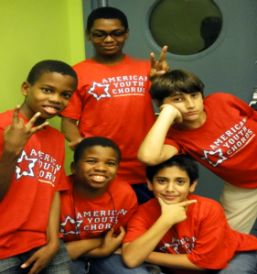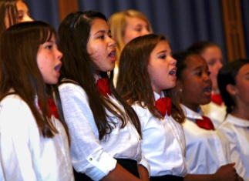

Performances venues have included:
The White House, U.S. Capitol Building, State Department, Library of Congress, National Archives,
The Kennedy Center for the Performing Arts, National Building Museum, Washington Nationals Park

For more information and to see a video of the American Youth Chorus in performance, visit our website at:
congressionalchorus.org

The American Youth Chorus is a community education program of CONGRESSIONAL CHORUS.

