Phil 413 Productions Presents:
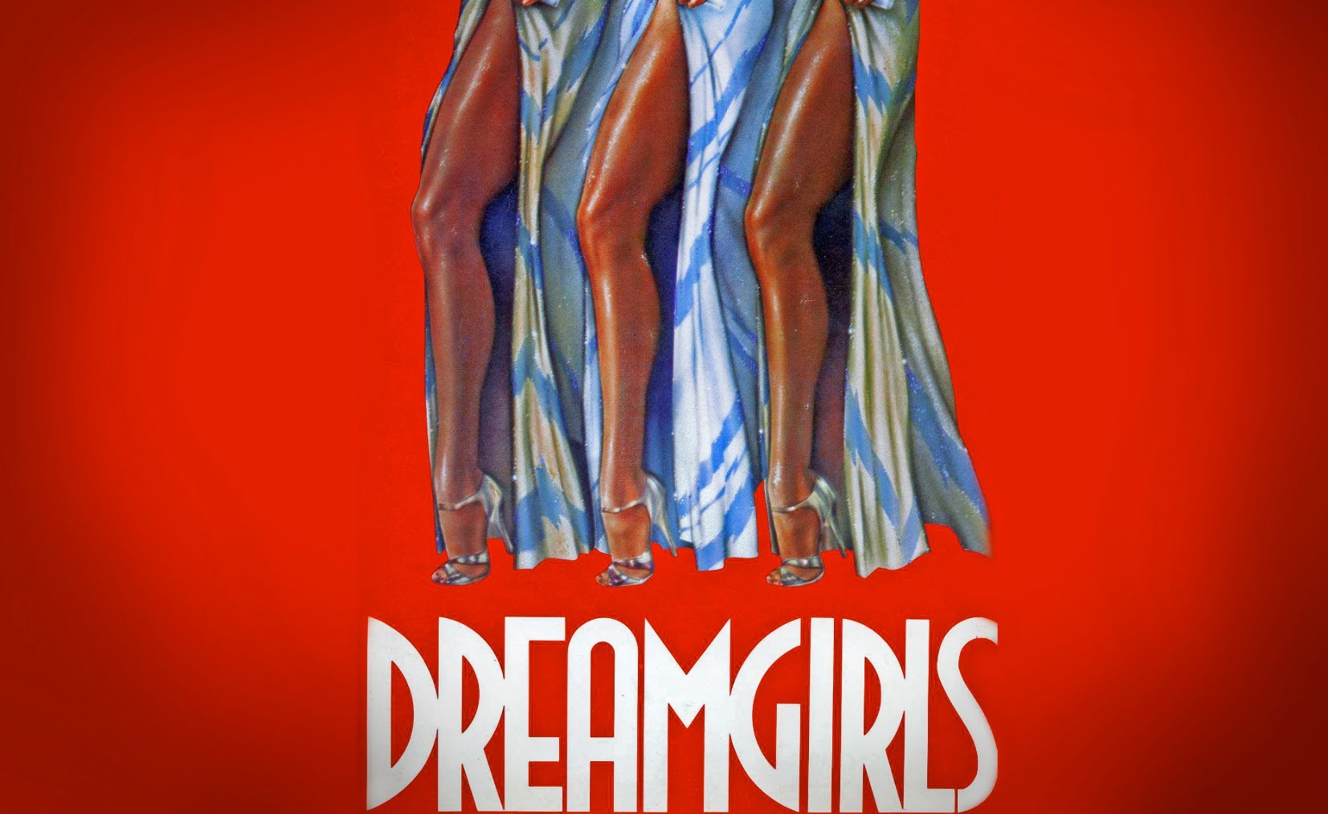
The Musical Auditions
October 10th and 11th at 6:00pm

Please Prepare:
*A 16 to 32 bars of a song in the style of the show
(Please do not sing from the show)
Accompanist will be provided or you can bring a CD
*Head shot and Resume stapled together
*A 50-70 word Bio

Location:
17555 Mauna Loa st. Hesperia CA 92345

Show Dates:
January 19-22nd 2017 at the High Desert Center for the Arts
15615 8th street Victorville CA

For more information and character breakdowns please visit:
https://www.facebook.com/phil413pro/

