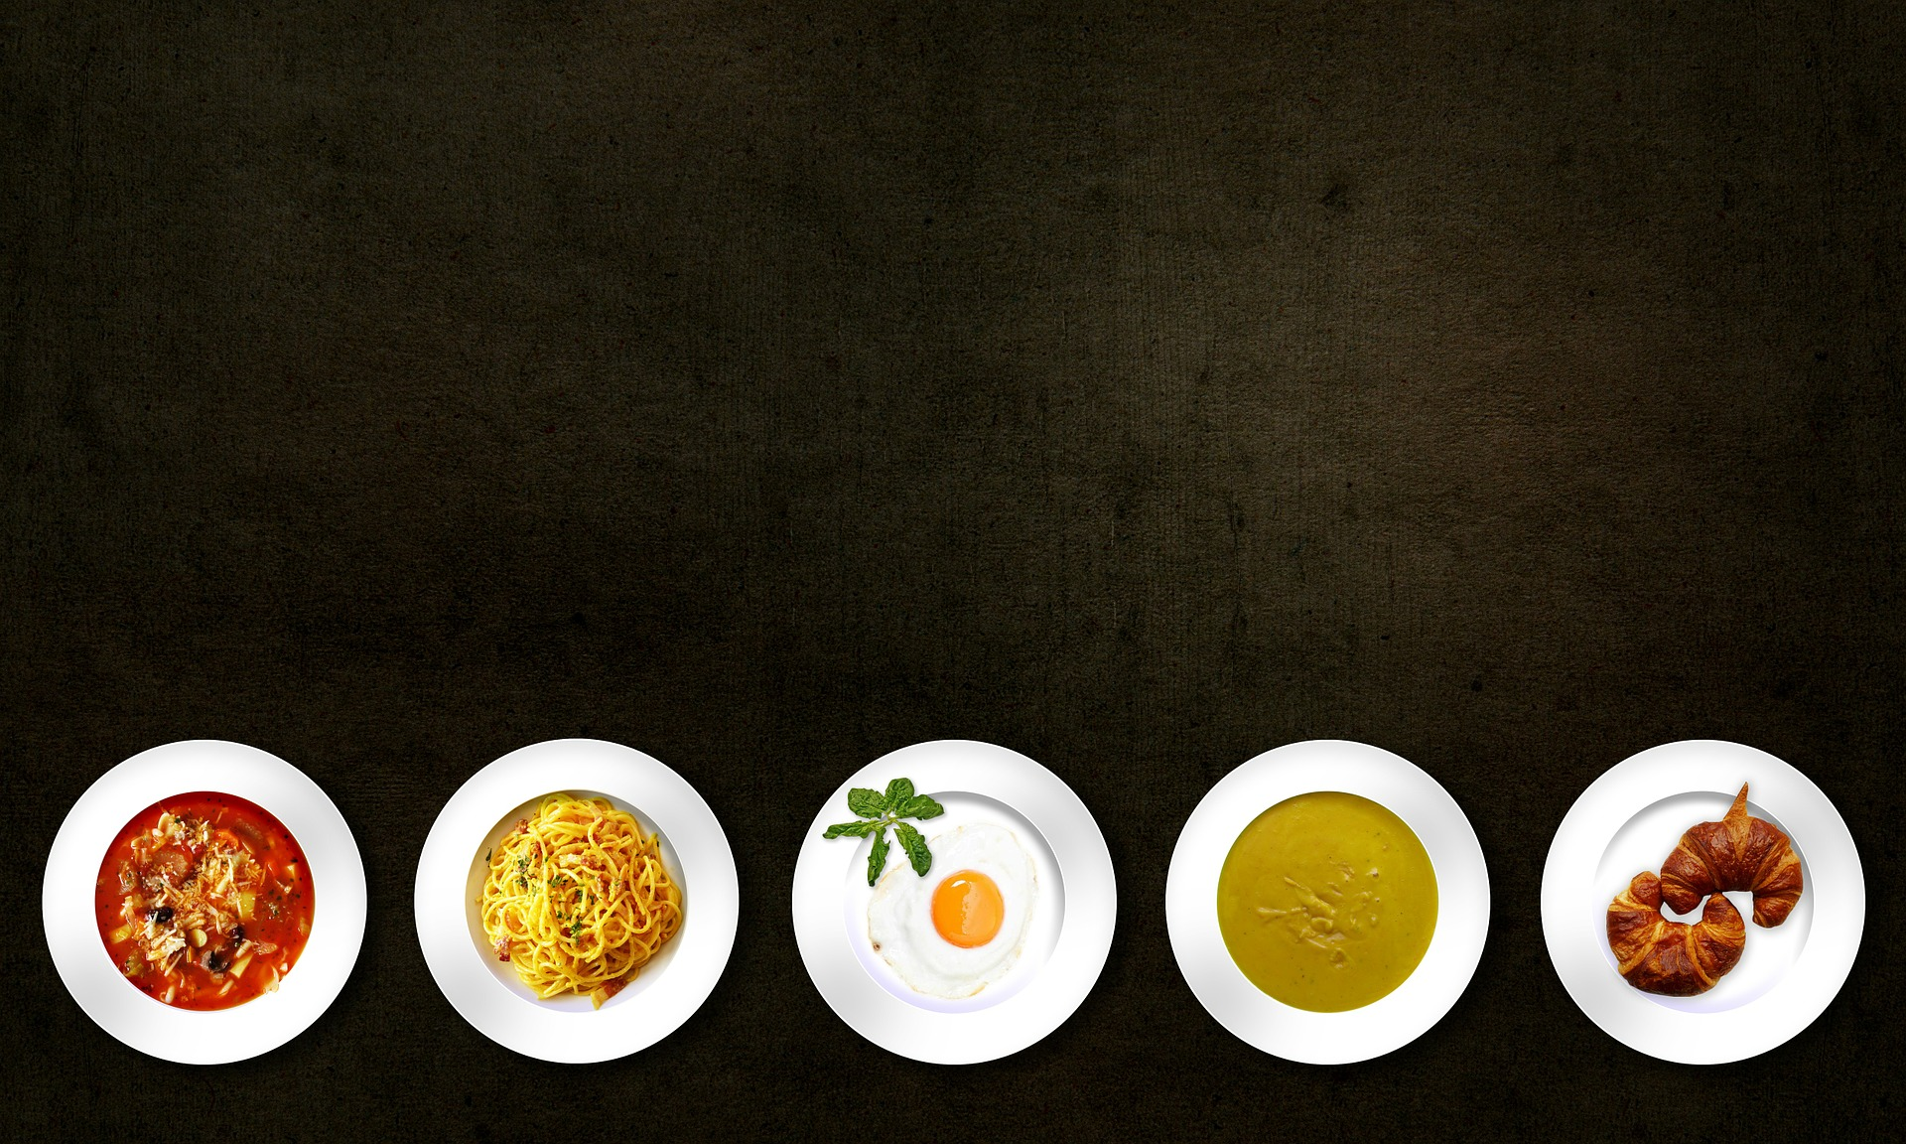
Ever Wish You Could Rub Shoulders with the Stars of the Food Network?

Are you a talented chef who simply lacks the connections and exposure to break through to the next level?
_________________
NOW CASTING

Do you own a restaurant that is a few tweaks away from becoming the success you always hoped it would be?

Are you an aspiring young cook with dreams of becoming a world-class chef?

Would you give anything to get face time with some of the most powerful
people in the culinary industry, including celebrity chefs from
The Food Network?

A new docu-series filming in New York is looking to help people like YOU make their culinary dreams come true by attending the events of the Food Network and Cooking Channel NYC Wine and Food Festival, October 13-16, 2016!

Seeking males/females, all ethnicities, 18+ who answered yes to at least one of the questions above.
_______________________________

Email or send us a video explaining in detail why you deserve this once-in-a-lifetime opportunity!

partycrashcasting@gmail.com

