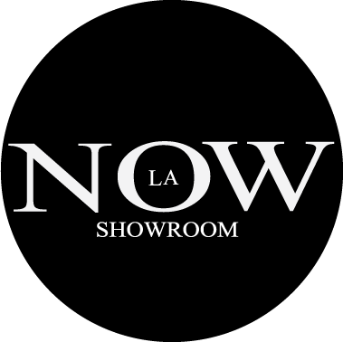
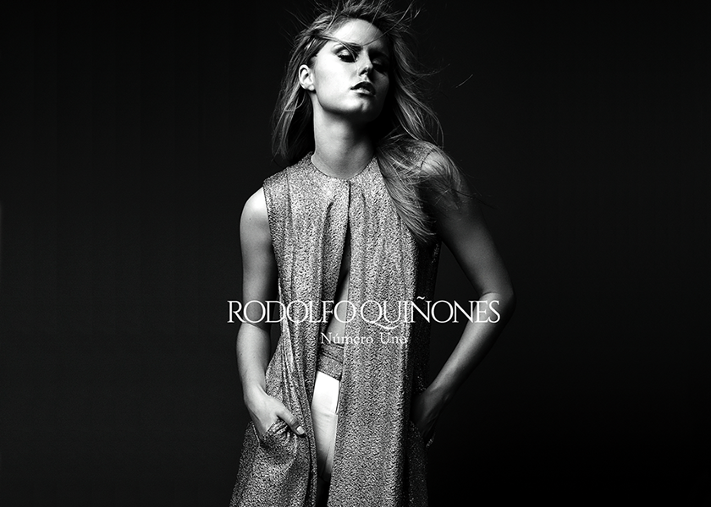

NOW-SHOWROOM PR is looking for models for an upcoming press preview, for Rodolfo Quinones line.

We are looking for female models that are around 5’8”, size 0-2, and are available on October 19th for 2-3 hours.

The walk-in casting call will take place on October 10th, from 12-2pm in The Gerry Building in DTLA.
910 S Los Angeles St. Suite 806,
Los Angeles, CA 90015
213-892-1615

Please bring a headshot, full length photo, and comp card if you have one.

Any questions contact Kristie@now-showroom.com

http://www.now-showroom.com
https://www.instagram.com/now_showroom/
http://rodolfoquinones.net/index.html

