Presents
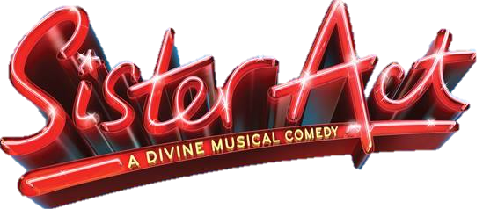
Director: Donna Tellier
Music Director: Eric W Van Dervort
Choreographer: Brieanna Tellier & Donna Tellier

AUDITIONS
Tuesday, November 15th All Roles
6:00 pm
&
Friday, November 18th All Roles

Performances
March 17th & 18th, &24th
@7:00pm
March 25th
@2:00pm and 7:00pm

Must be available for all technical rehearsals, dress rehearsals & performances.
For more information on roles available go to our Facebook page Johnston Dance and Performing Arts.

