Seeking two talented Actors (aged 11-15) to star in a Short Film (Working Title: I Will Dare) to be shot in Princeton Junction. No previous acting experience necessary and no need to prepare anything for the audition.

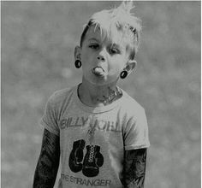

Audition Date and Time:
Saturday November 19th, 10am – 4pm
Audition Location: West Windsor Arts Council Firehouse Loft - 952 Alexander Rd, Princeton Junction, NJ

Please email Adam McGill at adamsylvanmcgill@gmail.com to schedule an audition time –
(Walk-ins are also welcome and if you are unable to attend in person we are willing to audition by appointment via skype!)

Synopsis:
I Will Dare is the story of two rebellious Teenagers who decide to give each other tattoos while their parents are away. This short film will explore themes of teenage rebellion, homemade tattoo guns, and friendship.
Seeking the following roles:

[SAM] [MALE or FEMALE] [Age 11-15] - An early teenage punk kid, Sam has dreamed for years of having a tattoo of his/her own to be like his/her rock idols. When Sam’s parents leave for the afternoon, Sam sees the perfect opportunity to make that dream come true. Sam is a little on the shy side, but a push from his/her best friend Casey usually puts Sam out of his/her comfort zone.
[CASEY] [MALE or FEMALE] [Age 11-15]- Sam’s closest and equally ink-obsessed best friend, Casey is the perfect partner in crime. Always eager and full of energy Casey likes to dive recklessly into adventure and mischief.
Questions: Call (609-273-2748) or email (adamsylvanmcgill@gmail.com) Adam McGill

