Casting Call
Student film - Castile
Synopsis:
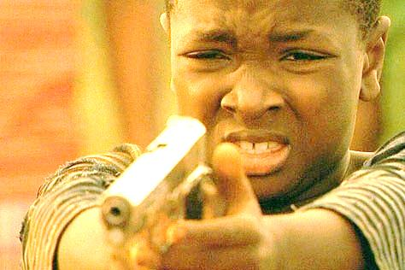
Inspired by the shooting of Philando Castile (African-American man shot and killed by the police when reaching for his license in Minnesota in 2016). Fictionalized nephew of Castile, Deon, is mourning the death of his uncle and enraged at the police officer, Greg, who shot Castile. The mother of the child comes home to an empty house and finds clues that lead her to believe that her son is on his way to get revenge on the cop. It is a race to see who gets to Greg first. If she can stop her son or if her son can get the revenge he is longing for. This is a story that will have you on the edge of your seat with an ending that will have you stunned.
Characters:
Deon: African-American (preteen – teenager look) Quiet and mysterious. Concentrated on finding Greg and focused on his pain.
Jewel: Mother of Deon. African-American woman, late 30s or early 40s. She is worried to the highest degree that her child will ruin his life forever.
Street Preacher: Street preacher who goes every week on the train preacher and reciting Dr. Martin Luther King Jr. Ideally looking for an older gentlemen with a Caribbean accent. But this role is open to whoever to audition.
Greg: Relaxing at home on paid leave. Hears a knock on the door and not expecting visitors. Searching for a Caucasian or Hispanic man in his older 20s, ideally with a solid build.
Security Guard: Good hearted fellow who isn't trying to make trouble, but rather just look out for people. Ideally an African-American gentlemen.

Contact Information: aarodcasting@gmail.com
Please send over headshot and which role you would like to audition for and I will respond as soon as I can. I will be holding skype auditions or recorded videos can be sent to the email address. Filming TBD, but most likely the last weekend of February and the first weekend of March.

