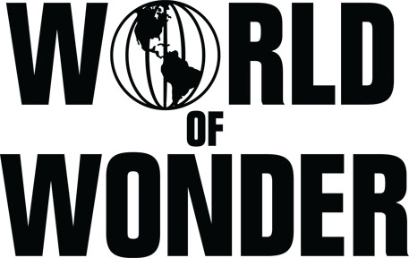

NOW CASTING IN NEW YORK, HOUSTON & CHICAGO:

Mothers who manage their child’s career!

Seeking fun and outrageous Mother/Child duos to star in new Docu-Series produced by Emmy winning production company World of Wonder!

- Are you a dynamic “stage mom” who’s guiding the career of a talented teen or young adult?
- Is your child the next superstar actor, singer, dancer, rapper, YouTube or pageant star?
- Is your life all about acting classes, auditions, pageants, meetings and call backs?
- Is your personality as big as your child’s…or even bigger?

This exciting new Major Cable Network series will spotlight “Momagers” and their hard work and dedication as they guide their young star’s rise to the top. All while showcasing their child’s talent on national television!

Seeking moms with kids aged 15 to 21 years old who are based in the New York, Houston or Chicago areas:

Apply today at: www.thecastingfirm.com/Momagers

Email Hollyewolfe@gmail.com if you have any questions!

* Must be legal US Residents.

