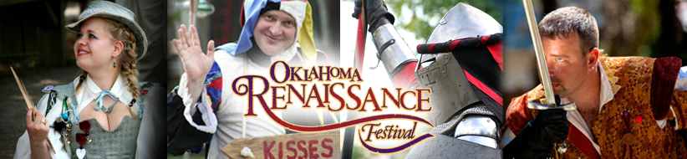

Casting for the 25th Annual Oklahoma Renaissance Festival
The Oklahoma Renaissance Festival will hold its open auditions for 2020 on Sunday, January 12th between 9:00am and 5:00pm. Auditions will be held at the Castle of Muskogee located at 3400 West Fern Mountain Rd Muskogee, Oklahoma 74401

The Festival runs 6 weekends for a total of 14 days - Saturdays and Sundays, starting April 25th including Memorial Day Weekend, through May 31st.

The Oklahoma Renaissance Festival (OKRF) has a variety of opportunities for energetic people with a wide range of performance experience and skills. The auditions are for performers who want to be a part of our Cast and have prior experience.
All cast members are paid positions based on the tiering of the role and experience.
Even those with no experience but the proper attitude and aptitude we encourage to join our Apprentice Ranks.
- All Cast are Paid
- Modest Lodging Available for Weekend Show Support
- Breakfast & Lunch provided during festival

Characters for Audition
Tier 1
- Mary Queen of Scots [Single weekend commitment]
Tier 2

- Robert Devereux, 2nd Earl of Essex
- Sir Francis Walsingham
- Gómez Suárez de Figueroa y Córdoba, 1st Duke of Feria
- Bertrand de Salignac de La Mothe-Fénelon
- Lady Elizabeth Knollys
- Lady Elizabeth Throckmorton
- Lady Frances Walsingham
- Lady Anne Vavasour
- Never World Beggar/Mummers [x6]

Tier 3
Apprentice Cast No Audition required [Chorus of Assigned Roles]

Bradley Rasher the Butcher
Lilliana May the Gardener
Beauregard Tubbins the Baker
Martha Nash Midwife
Dylan Armstrong Miller
Abagail Prue Milkmaid
Allyn Pierce Gamekeeper
Prudence Sterling Moneylender’s Wife
Bartholomew Jackson Carpenter
Gretchen Hogarth Cook
Crispin Dodger Messenger
Sarah Sharp Seamstress
Hamilton Riggs Tower Yeoman- Commissary Officer
Maxwell Keen Tower Yeoman-Lookout
Roger Stockbridge Tower Yeoman-Quartermaster
Edgar Nevermore Tower Yeoman-Raven Master
Pillar Svengaro Dancer
Sorsha Svengaro Dancer
Arellia Svengaro Shivani
Vano Svengaro Caravan Master
Lash Svengaro Protector
Kezia Svengaro Herbalist

Participants wishing to audition must contact the organizer at donryan@me.com. Or call 405-919-8267 to schedule a time. There will be options for walk-in first come first serve.

Requirements for Scheduling Audition Slot:
- Full name, address, phone and email address
- A headshot (or a recent photo of your face) and a theatrical resume
- Be prepared to sing and do two monologues, one classical and one contemporary. In a dialog reflective of the character. Monologues should not exceed two minute each.
- All cast members must be at least 18 by Festival Season.

Those selected from the auditions will become a part of the Festival's training program, the Oklahoma Renaissance Actors (OKRA) Academy.

About the Festival
Starting in 1996, the Oklahoma Renaissance Festival offers fine arts & crafts with food and entertainment of 16th century England. Renaissance Festival (Ren Festival or just Festival) is an amalgam of many things. It’s partly an artisans/craft fair, it’s partly historical reenactment, and it’s partly performance art. Everyone working at Festival dresses in costumes (or garb) typical of the late Tudor period. There are many booths selling both crafts and food. Parades wind their way through the crowds. Jugglers, musicians, magicians, and other entertainers perform through the day. One can wander about, examining goods for sale, sampling foods, watching plays and performers, and of course drinking fyne English Ale.

For more information and details about the Oklahoma Renaissance Festival please visit
http://okcastle.com/
https://www.okraa.org/
https://www.facebook.com/OKRAA-Oklahoma-Renaissance-Actors-Academy-181315212419414/

